**FPT ACADEMY INTERNATIONAL**



**FPT – APTECH COMPUTER EDUCATION**

# King Shop

|  |  |  |  |
| --- | --- | --- | --- |
| **Center Name** | | FAI – Ho Chi Minh  Address: 21 bis Hau Giang, Tan Binh District , Ho Chi Minh City, VietNam. | |
| **Instructor** | | Mr. Tran Phuoc Sinh | |
| **Class** | | T1.2311.M0 | |
| **Group** | | 5 | |
| **Group members** | | **Name** | **Student ID** |
| Nguyen Hai Hoang | Student1339262 |
| Tran Van Hung | Student1339266 |
|  |  |
|  |  |
| **Duration** | **Start date** | Nov 17th 2025 | |
| **End date** | Dec 24th 2025 | |

**Table of Contents**

**REVIEW 1**............................................................................................................................

ACKNOWLEDGE...............................................................................................................

INTRODUCTION................................................................................................................

PROBLEM DEFINITION ....................................................................................................

CUSTOMER'S REQUIREMENTS SPECIFICATIONS (CRS) ...........................................

CLIENT:..............................................................................................................................

TASK SHEET REVIEW 1 ..................................................................................................

**REVIEW 2** ...........................................................................................................................

1. USECASE.......................................................................................................................

2. DATA FLOW DIAGRAM (DFD)......................................................................................

3. ENTITY PROPERTIES ..................................................................................................

4. TABLE DESIGN..............................................................................................................

5. TASK SHEET REVIEW 2 ..............................................................................................

**REVIEW 3** ...........................................................................................................................

1. VIEW ADMIN..................................................................................................................

2. VIEW USER ...................................................................................................................

3. Task sheet review 3........................................................................................................

# REVIEW 1

**Acknowledgement**

It is often said that “Gratitude is the sign of noble souls”. That’s why we devote this chapter to express our deep gratitude towards those who have supported and guided us to accomplish this eProject successfully.

First and foremost, we appreciate the invaluable assistance that our beloved instructor - Mr. Tran Phuoc Sinh, has offered us. Whenever problems come up, she’ll always the one that we can count on for solutions. Moreover, there were moments when our team decided to give up our project, and Mr. Sinh gave us a pep talk to keep us back on the track.

Next, it would have been impossible to carry out and complete this project without the collaboration among our team members. Although we have gone through many obstacles during the project implementation, eventually we gained what we aimed at by our hard work, our strong commitment and of course, our brotherhood.

Finally, thanks to Aptech’s eProject assignment, we had a golden opportunity to apply what we have learnt into reality and gain hands-on experience which is essential for our future career.

**Introduction**

We are in an era where information technology makes buying and selling easier than ever. People can order anything they want, everything is done electronically and interacts in real time. Phone stores are no exception to this cycle. So we are developing a website named King-Shop to help you easily buy mobile phones with best deals online. Mobile phone stores are for organizations that want to develop online stores where visitors can be people who don't have much time to go to phone stores or people who have the habit of shopping online or simply they are in too far from independent stores. It will provide the following features to users.

For King Shop customer base:

- Unregistered visitors can register for a member account.

- Registered visitors can log in and manage their accounts.

- Visitors can search for any product such as Iphone, Oppo, Redmi, etc.

- Visitors can search for products by price.

- Visitors can view product descriptions before purchasing.

- Visitors can purchase products after adding products to the cart.

- Visitors can view cart history.

- Visitors can review order history and make changes.

- Visitors can rate purchased products.

- Visitors can interact with the website by asking questions and giving feedback on the contact us function.

**PROBLEM DEFINITION**

After analyzing the project specifications of King Shop, to fulfil customer’s requirements properly, we came to conclusion that in order to achieve the best result, we should deal with following queries:

**FROM THE VIEW POINT OF VISITORS:**

- A homepage will show the main products, suitable logo, display the logo on all the pages in the site.

- A navigation header and footer that will include all the functions implemented in the website.

- Visitor can buy products, add product to cart, view cart and check out.

- Registered visitors can login to their profile, view order history.

**FROM THE VIEW POINT OF THE ADMINISTRATOR:**

- A login page will grant access to King Shop admin.

- Admin can view, add, update and manage products.

- Admin can add, update, delete and manage orders.

- Admin can update and manage registered user account.

- Admin can manage and send newsletter.

**CUSTOMER'S REQUIREMENTS SPECIFICATIONS (CRS)**

**CLIENT: King Shop**

**BUSINESS/PROJECT OBJECTIVES:**

The project is to design an online website to advertise and sell mobile phones, such as: Iphone, Oppo, Redmi, etc.

**INPUT TO THE SYSTEM:**

* King Shop administrators need to provide:

- Necessary information to create an account to access the administration system.

- Products will be displayed on the website.

- Payment methods and shipping fees when ordering certain products.

- Necessary information to create employee accounts in the administration system.

* Customers King Shop need to provide:

- Personal information about product purchases.

**OUTPUT FROM THE SYSTEM:**

* King Shop administrators will be able to:

- Login/Logout to the admin system.

- Manage (view, add, update, hidden) products, price.

- Manage (view, add, update) news.

- Manage (view, add, update) products, order.

* King Shop guests will be able to:

- Register customer account.

- Buy products after add information.

- View products that they have chosen.

- View order history.

* King Shop customer will be able to:

- Register account.

- Login/Logout to the account.

- Search products they want to buy by name, price.

- Add product to cart and checkout.

- View purchase history.

**DATABASE:**

- The information about products, customers, news, orders cart will be stored in the database.

- The information from the contact us page.

### 

**HARDWARE/ SOFTWARE REQUIREMENTS:**

**HARDWARE**

**Web Server**

|  |  |
| --- | --- |
| **Processor** | Intel Core I5 or higher. |
| **Memory** | 32 GB RAM or greater. |
| **Modem/ADSL** | Internet access is required. |

**Client**

|  |  |
| --- | --- |
| **Processor** | Intel Core I3 or higher. |
| **Memory** | 8 GB RAM or greater. |
| **Monitor** | Super VGA (1024x768) or higher resolution. |
| **Modem/ADSL** | Internet access is required. |

**SOFTWARE**

**Web Server**

|  |  |
| --- | --- |
| **Operation System** | Window 10 or later. |
| **Browser** | Google Chrome version 35. |
| **Database** | MySQL. |
| **Software** | Spring Boot (Java) – Restful API |
| Apache Tomcat (embedded trong Spring Boot) |
|  | Internet Information Services (IIS) |

**Client**

|  |  |
| --- | --- |
| **Operation System** | Window 10 or higher. |
| **Browser** | Google Chrome version 35. |

**DEVELOPMENT SOFTWARE**

- Microsoft Windows 10.

- MySQL.

- IntelliJ IDEA

- Visual Studio Code.

- Google Chrome.

- Postman / Insomnia (kiểm thử API).

- Git / GitHub

**TECHNOLOGY**

- PHP - Laravel framework.

**- Java – Spring Boot (RESTful API)**.

- Spring Data JPA / Hibernate.

- MySQL Database.

- JavaScript (Frontend).

- HTML / CSS / Bootstrap.

- jQuery.

**TASK SHEET REVIEW 1**

|  |  |  |  |  |  |  |  |  |
| --- | --- | --- | --- | --- | --- | --- | --- | --- |
| **Project Ref. No.:** | | **Project Title:** | **Activity Plan Prepared By:** | **Date of Preparation of Activity Plan:** | | | | |
| **Sr.**  **No.** | **Task** | **Actual Start Date** | | **Actual Days** | **Team Mate Names** | **Status** |
| 1 | Acknowledgement | King Shop | All member | 17/11/2025 | | 1 | Hung | Completed |
| 2 | Problem Definition | 17/11/2025 | | 1 | Hung | Completed |
| 3 | Requirement Specification | 17/11/2025 | | 1 | Hung | Completed |
| 4 | Task sheet review | 17/11/2025 | | 1 | Hung | Completed |
| **Date: 18/11/2025** | | | | | | | | |
| Signature of Instructor:  **Mr. Tran Phuoc Sinh** | | | | | Signature of Team Leader:  **Nguyen Duy Anh** | | | |

# REVIEW 2

**I: USE CASE**

**1. USER**

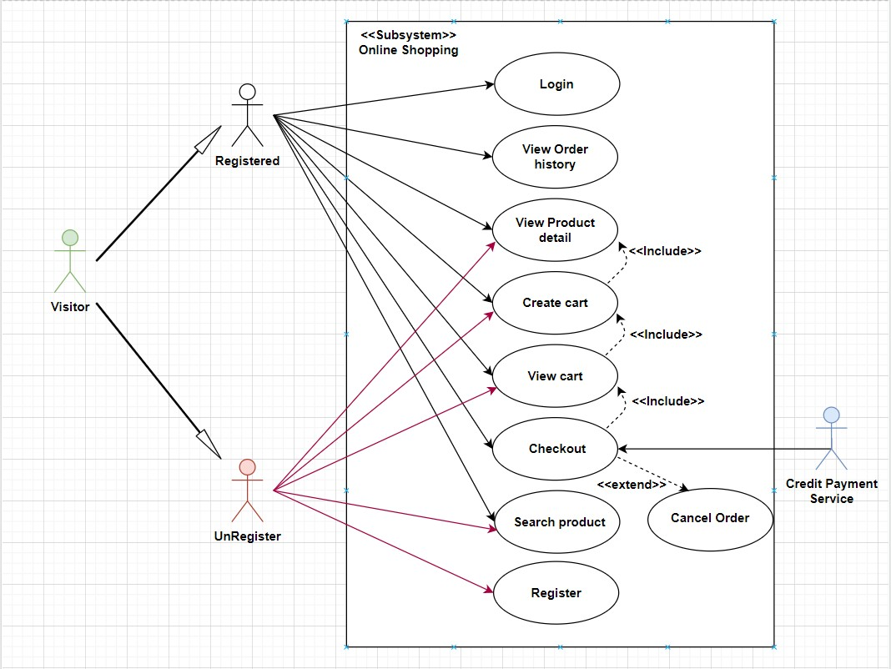

Login

|  |  |  |
| --- | --- | --- |
| **Use Case Name** | Login | |
| **Actors** | User | |
| **Description** | Users with accounts can log in | |
| **Requirements** | User provides username and password | |
| **Pre-conditions** | The user already has an account. | |
| **Post-conditions** | Success: User logs into the website | |
| Failure: Login failed message | |
| **Basic flow** | **Actor’s actions:** | **System’s responses:** |
| 1. User opened the link to the Login Page | 2. The system redirects to the Login Page with the following content control:  "Username" text field  "Password" text field  "Login" button |
| 3. User enters Username and Password, then clicks 'Login' button. | 4. The system checks the information. |
|  | 5. The system redirects to the Home page. |
| **Exceptions** | **Actor’s actions:** | **System’s responses:** |
| 1. User entered invalid username or password | 2. The system displays the message: "Invalid username and password" |

Register

|  |  |  |
| --- | --- | --- |
| **Use Case Name** | Register | |
| **Actors** | User | |
| **Description** | User requests account | |
| **Requirements** | User provides personal information | |
| **Pre-conditions** | User has not been granted an account | |
| **Post-conditions** | Success: User has an account to purchase products from the Shop | |
| Failure: Account creation failed messag | |
| **Basic flow** | **Actor’s actions:** | **System’s responses:** |
| 1. User opens the personal information form on the registration page |  |
| 2. User fills in personal information on the registration form, then clicks the Submit button | 3. The system saves the user information to the database as 'not activated' and sends a verification email to the user |
| 4. User presses the verification button on the email to verify that he is not a robot | 5. The system changes the account status to 'activated' and redirects the user to the Home page |
| **Exceptions** | **Actor’s actions:** | **System’s responses:** |
| 1. User entered invalid username or password | 2. The system displays the message: "Invalid username and password" |

See product details

|  |  |  |
| --- | --- | --- |
| **Use Case Name** | See product details | |
| **Actors** | User | |
| **Description** | Users want to see product details | |
| **Requirements** | User selects product wants to see detailed information | |
| **Pre-conditions** | Users can access the web | |
| **Post-conditions** | Success: User can view product details | |
| Failure: Report error and return to Home page | |
| **Basic flow** | **Actor’s actions:** | **System’s responses:** |
| 1. User selects the product they want to view detailed information | 2. System redirects to the product detail page that User selected |
| 3. User views and can add product to cart if they want to buy | 4. System adds product to cart if User adds to cart |
|  |  |

View cart

|  |  |  |
| --- | --- | --- |
| **Use Case Name** | View cart | |
| **Actors** | User | |
| **Description** | Users want to see cart details | |
| **Requirements** | User views his cart | |
| **Pre-conditions** | Users can access the web | |
| **Post-conditions** | Success: User can view his cart | |
| Failure: Report error and return to Home page | |
| **Basic flow** | **Actor’s actions:** | **System’s responses:** |
| 1. User accesses the cart | 2. System redirects to the user's cart page |
| 3. User views the cart, removes the product if they no longer need to buy it, adjusts the product quantity |  |
| 4. User confirms the cart and selects payment | 5. System creates an order for the User |
|  |  |

Checkout cart

|  |  |  |
| --- | --- | --- |
| **Use Case Name** | Checkout cart | |
| **Actors** | User | |
| **Description** | User wants to pay | |
| **Requirements** | The user already has products in the cart | |
| **Pre-conditions** | Users can access the web | |
| **Post-conditions** | Success: User successfully pays for the order and waits for confirmation from the Shop | |
| Failure: Report error and return to Home page | |
| **Basic flow** | **Actor’s actions:** | **System’s responses:** |
| 1. User enters delivery address information, reviews order and selects payment method and clicks 'Confirm Purchase' | 2. System saves order information and updates order list for Administrator. |
| 3. User waits and views order status in order history |  |
|  |  |
| **Exceptions** | **Actor’s actions:** | **System’s responses:** |
|  |  |

View purchase history

|  |  |  |
| --- | --- | --- |
| **Use Case Name** | View purchase history | |
| **Actors** | User | |
| **Description** | Users want to see purchase history | |
| **Requirements** | Users have placed orders | |
| **Pre-conditions** | Users can access the web | |
| **Post-conditions** | Success: Users can view purchase history and order status | |
| Failure: Report error and return to Home page | |
| **Basic flow** | **Actor’s actions:** | **System’s responses:** |
| 1. User accesses the purchase history page | 2. System redirects to User's order history page |
| 3. User can view the latest order status and old orders |  |
|  |  |
| **Exceptions** | **Actor’s actions:** | **System’s responses:** |
|  |  |

See news details

|  |  |  |
| --- | --- | --- |
| **Use Case Name** | See news details | |
| **Actors** | User | |
| **Description** | Users view news details | |
| **Requirements** | Users click to see news details | |
| **Pre-conditions** | User opens news page | |
| **Post-conditions** | Success: User can see article details | |
| Failure: Error message | |
| **Basic flow** | **Actor’s actions:** | **System’s responses:** |
| 1. User opens the news page |  |
| 2. User selects the news he wants to see in detail | 3. System redirects to that article page |
| 4. User can Like and Comment on that article | 5. System saves user's comments |
| **Exceptions** | **Actor’s actions:** | **System’s responses:** |
| 1. User opens the news page | 2. System reports error and returns to Home page |

**2. ADMIN**

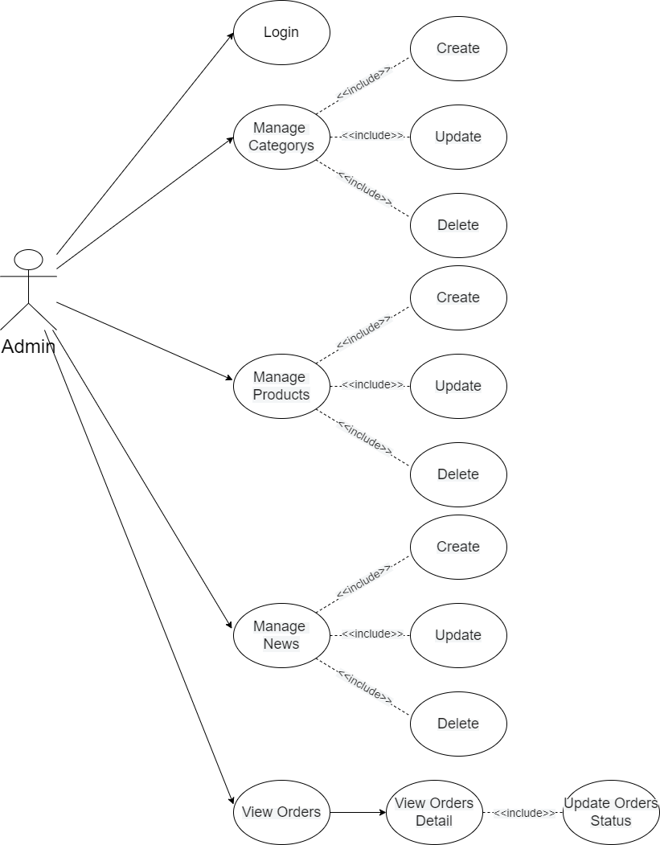

Login

|  |  |  |
| --- | --- | --- |
| **Use Case Name** | Login | |
| **Actors** | Admin | |
| **Description** | When the Administrator wants to manage Orders, Categories, Products and News | |
| **Requirements** | Admin provides username and password | |
| **Pre-conditions** | Admin must be exist on database | |
| **Post-conditions** | Success: Admin is logged in to website admin | |
| Failure: Login failed message | |
| **Basic flow** | **Actor’s actions:** | **System’s responses:** |
| 1. Admin opened the link to the Login Page | 2. The system redirects to the Login Page with the following content control:  "Username" text field  "Password" text field  "Login" button |
| 3. Admin enters Username and Password, then clicks 'Login' button. | 4. The system checks the information. |
|  | 5. The system redirects to the Admin's dashboard. |
| **Exceptions** | **Actor’s actions:** | **System’s responses:** |
| 1. Admin entered invalid username or password | 2. The system displays the message: "Invalid username and password" |

Manage Orders

|  |  |  |
| --- | --- | --- |
| **Use Case Name** | Manage Order | |
| **Actors** | Admin | |
| **Description** | When the Administrator wants to manage the order | |
| **Requirements** | Admin go to order management(dashboard) section | |
| **Pre-conditions** | The administrator must exist on the database. | |
| **Post-conditions** | Success: Admin redirected to dashboard page | |
| Failure: Error message | |
| **Basic flow** | **Actor’s actions:** | **System’s responses:** |
| 1.Admin opens link to dashboard | 2. The system displays the list of orders |
| 3. Admin click to view order details | 4. The system redirects to the order details page |
| 5. Admin confirms 'approve' the order or 'cancels' the order | 6. The system records the Admin's action |
|  | 7. Order status changes to 'approved' and being delivered or cancelled by Admin |

Manage Categorys

|  |  |  |
| --- | --- | --- |
| **Use Case Name** | Manage Categorys | |
| **Actors** | Admin | |
| **Description** | When the Administrator wants to manage the category | |
| **Requirements** | Admin go to category management section | |
| **Pre-conditions** | The administrator must exist on the database. | |
| **Post-conditions** | Success: Admin redirected to category management page | |
| Failure: Error message | |
| **Basic flow** | **Actor’s actions:** | **System’s responses:** |
| 1.Admin opens link to category management | 2. The system redirects to the category management page |
| 3. Administrator selects to ‘add’ or ‘update’ categories | 4. The system will redirect to the category 'add' or 'update' page |
| 5. The administrator enters information into the form | 6. Input validation system |
|  | 7. System to 'add' or 'update' data to the database |

Manage Products

|  |  |  |
| --- | --- | --- |
| **Use Case Name** | Manage Products | |
| **Actors** | Admin | |
| **Description** | When the Administrator wants to manage the product | |
| **Requirements** | Admin go to product management section | |
| **Pre-conditions** | The administrator must exist on the database. | |
| **Post-conditions** | Success: Admin redirected to product management page | |
| Failure: Error message | |
| **Basic flow** | **Actor’s actions:** | **System’s responses:** |
| 1.Admin opens link to product management | 2. The system redirects to the product management page |
| 3. Administrator selects to ‘add’ or ‘update’ product | 4. The system will redirect to the product 'add' or 'update' page |
| 5. The administrator enters information into the form | 6. Input validation system |
|  | 7. System to 'add' or 'update' data to the database |

Manage News

|  |  |  |
| --- | --- | --- |
| **Use Case Name** | Manage News | |
| **Actors** | Admin | |
| **Description** | When the Administrator wants to manage the new | |
| **Requirements** | Admin go to new management section | |
| **Pre-conditions** | The administrator must exist on the database. | |
| **Post-conditions** | Success: Admin redirected to new management page | |
| Failure: Error message | |
| **Basic flow** | **Actor’s actions:** | **System’s responses:** |
| 1.Admin opens link to new management | 2. The system redirects to the new management page |
| 3. Administrator selects to ‘add’ or ‘update’ new | 4. The system will redirect to the new 'add' or 'update' page |
| 5. The administrator enters information into the form | 6. Input validation system |
|  | 7. System to 'add' or 'update' data to the database |

**II: DATA FLOW DIAGRAM**

**LEVEL 0**

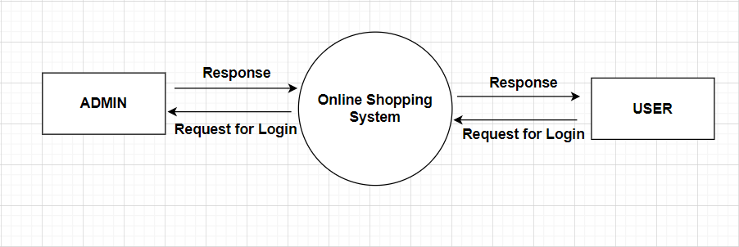

**ADMINSIDE LEVEL 1**

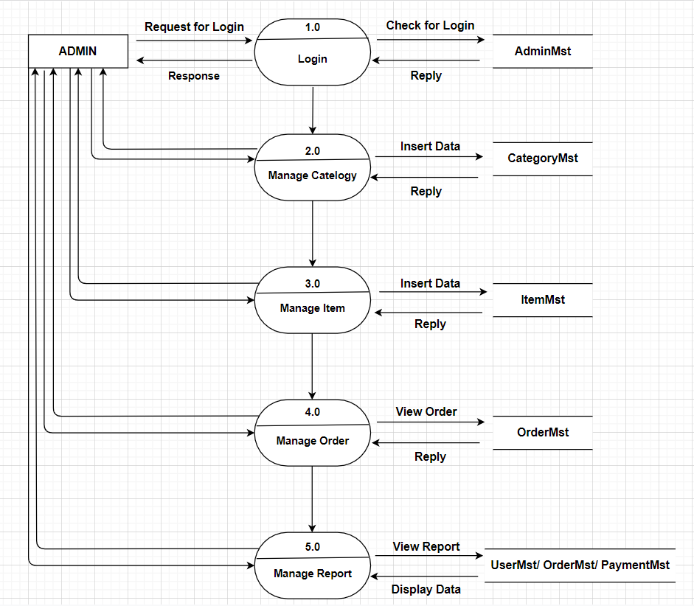

**ADMINSIDE LEVEL 2**

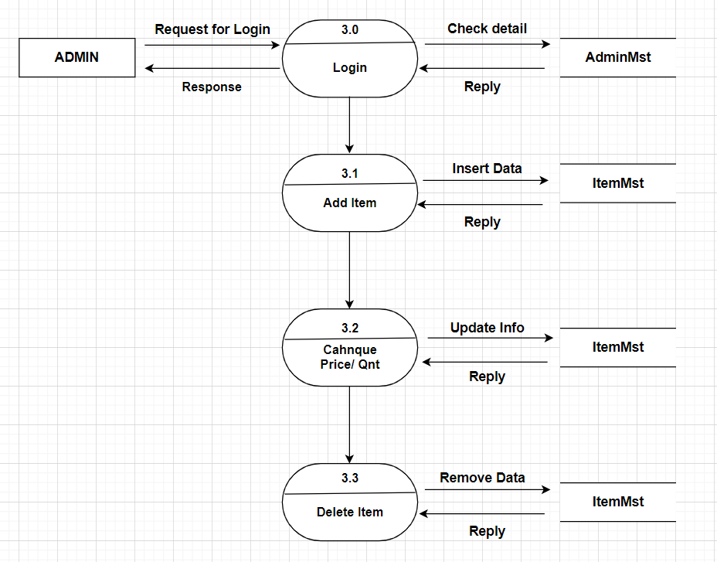

**ADMINSIDE LEVEL 3**

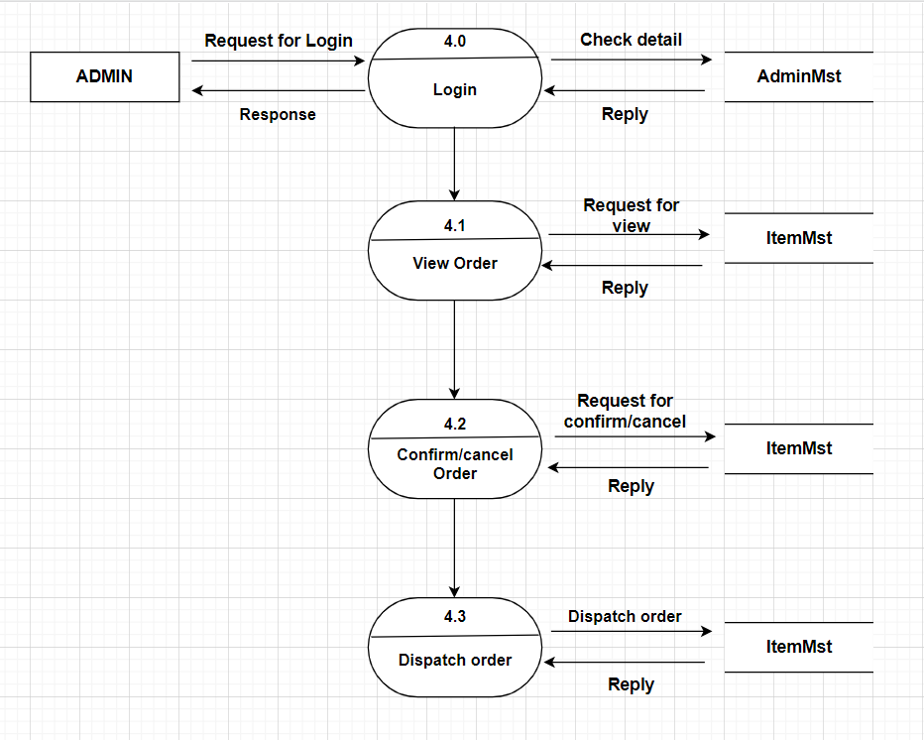

**USERSIDE LEVEL 1**

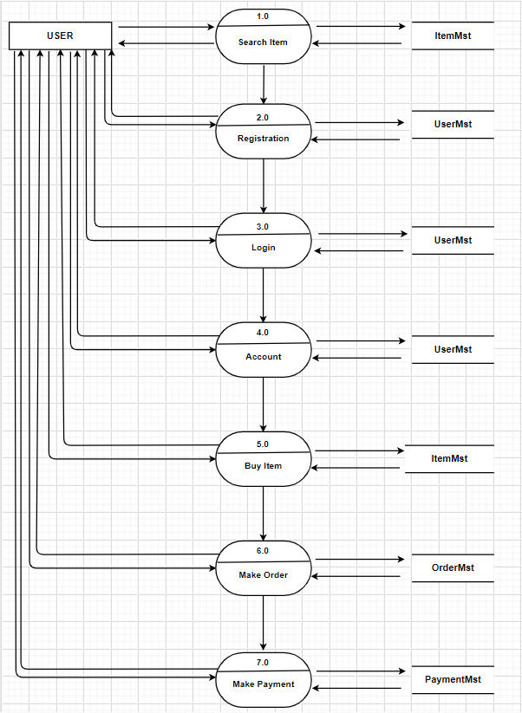

**USERSIDE LEVEL 2**

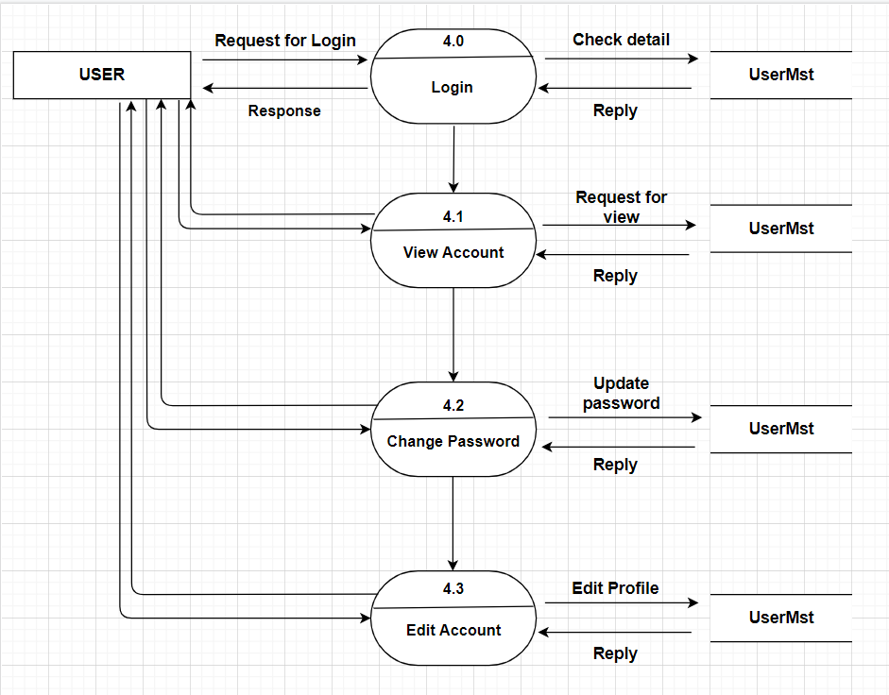

**USERSIDE LEVEL 3**

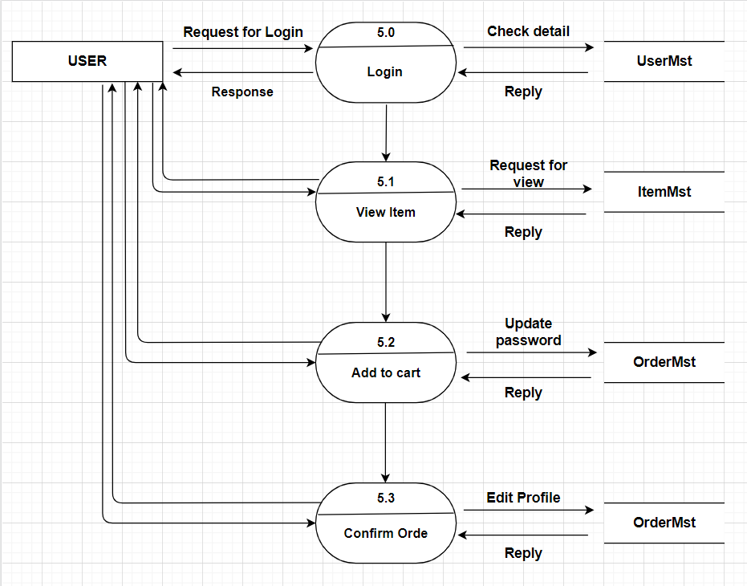

**III: ENTITY PROPERTIES**

USERS

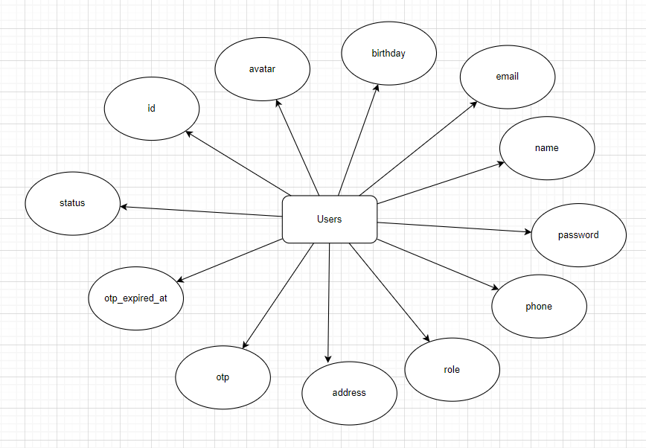

CATEGORY

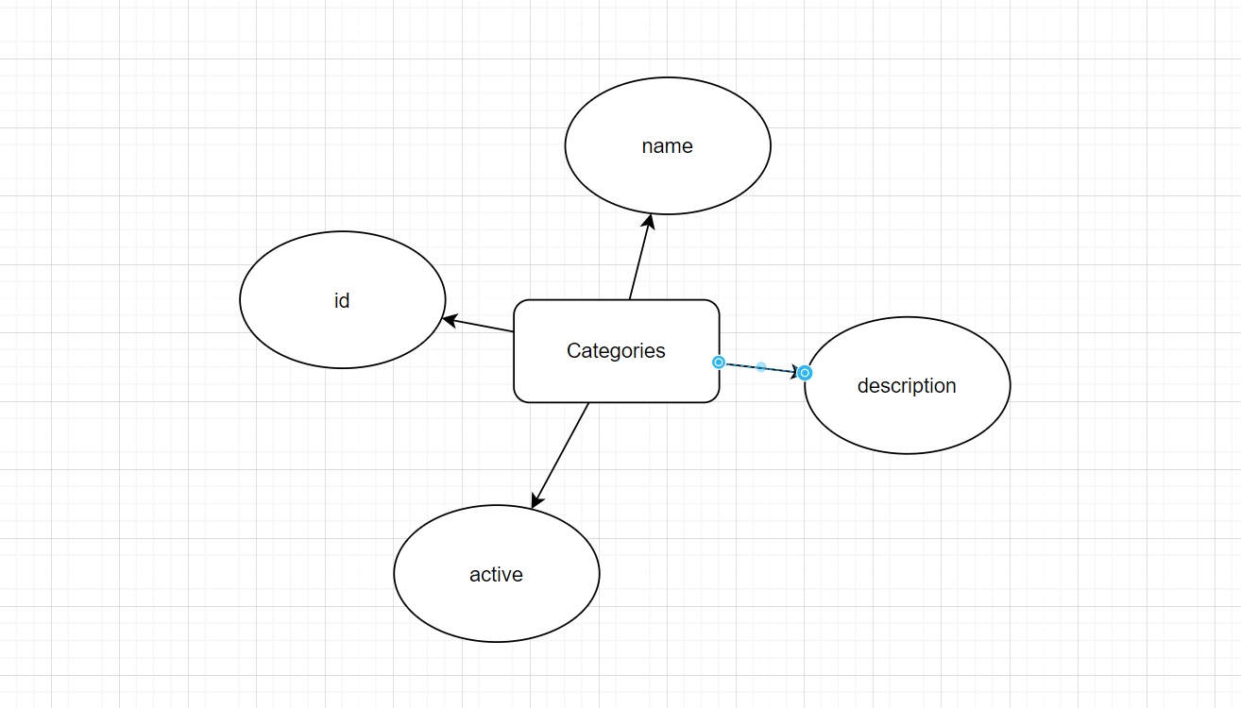

PRODUCT

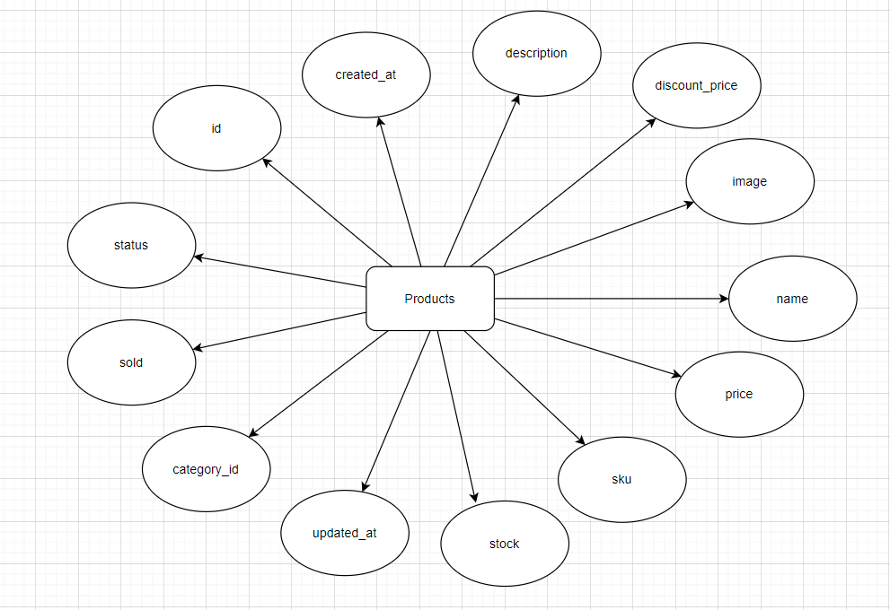

NEWS

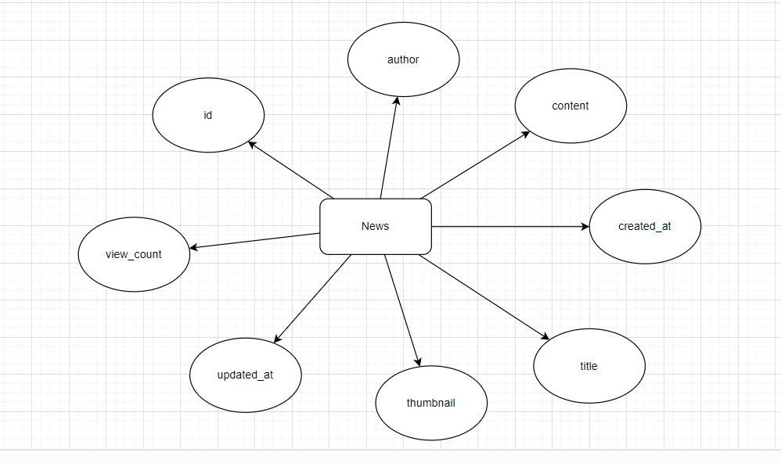

NEWS COMMENTS

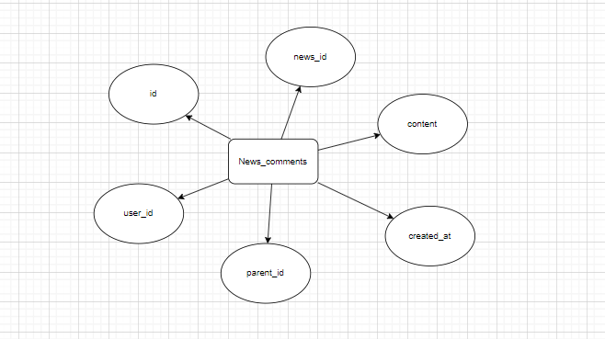

NEWS LIKES

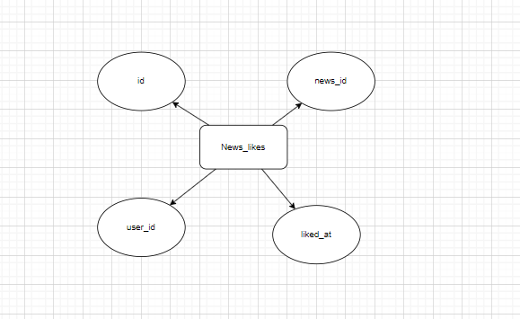

ORDER

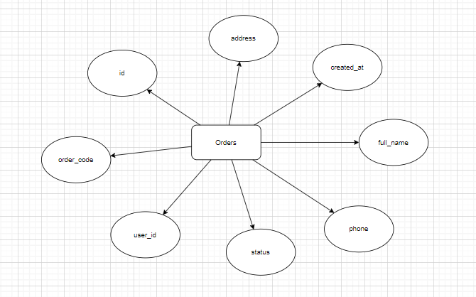

ORDER ITEMS

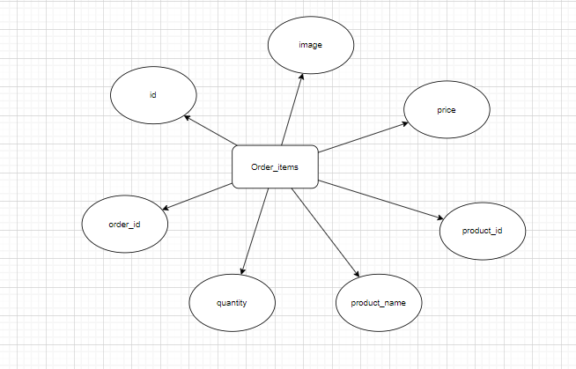

**IV: ENTITY RELATIONSHIP DIAGRAM (ERD)**

**LOGICAL ERD**

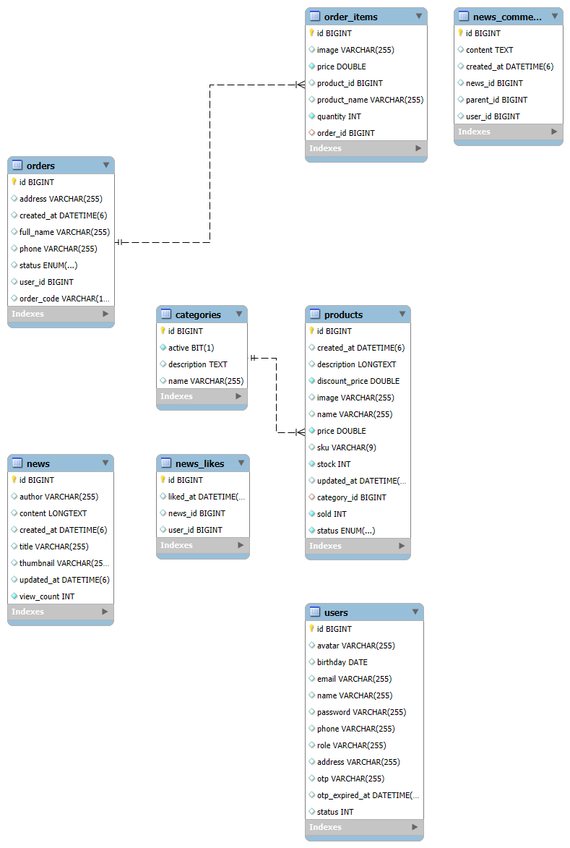

**DESIGN TABLE**

TABLE USERS:

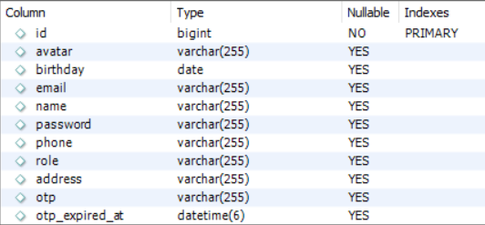 

TABLE PRODUCTS:

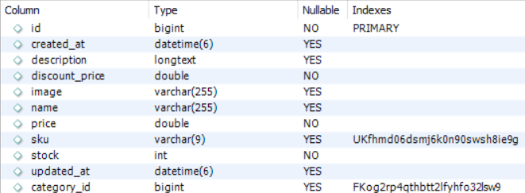 

TABLE CATEGORIES:

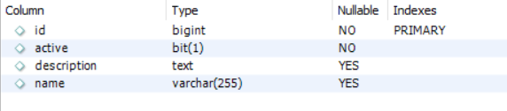

TABLE NEWS:

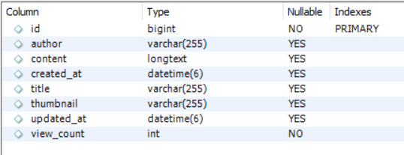

TABLE NEWS_COMMENTS:

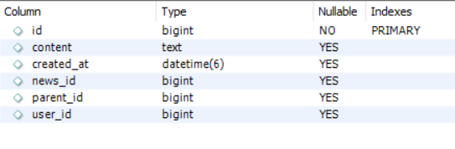

TABLE NEWS_LIKES:

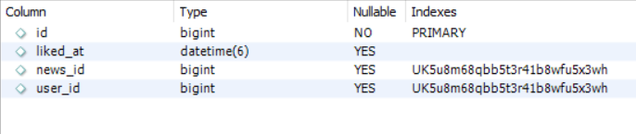

TABLE ORDERS:

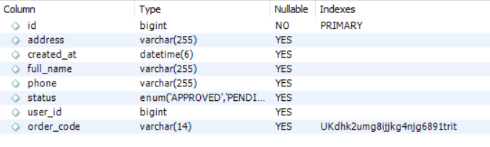

TABLE ORDERS:

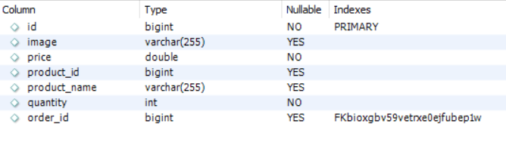

**TASK SHEET REVIEW 2**

|  |  |  |  |  |  |  |  |  |
| --- | --- | --- | --- | --- | --- | --- | --- | --- |
| **Project Ref. No.:** | | **Project Title:** | **Activity Plan Prepared By:** | **Date of Preparation of Activity Plan:** | | | | |
| **Sr.**  **No.** | **Task** | **Actual Start Date** | | **Actual Days** | **Team Mate Names** | **Status** |
| 1 | Use Case | King Shop | All member | 29/11/2025 | | 2 | Hung | Completed |
| 2 | Data Flow Diagram | 29/11/2025 | | 2 | Hung | Completed |
| 3 | Entity Properties | 1/12/2025 | | 3 | Hung | Completed |
| 4 | Task sheet review | 1/12/2025 | | 3 | Hung | Completed |
| **Date: 18/11/2025** | | | | | | | | |
| Signature of Instructor:  **Mr. Tran Phuoc Sinh** | | | | | Signature of Team Leader:  **Nguyen Duy Anh** | | | |

# REVIEW 3

**ADMIN**

Dashboard

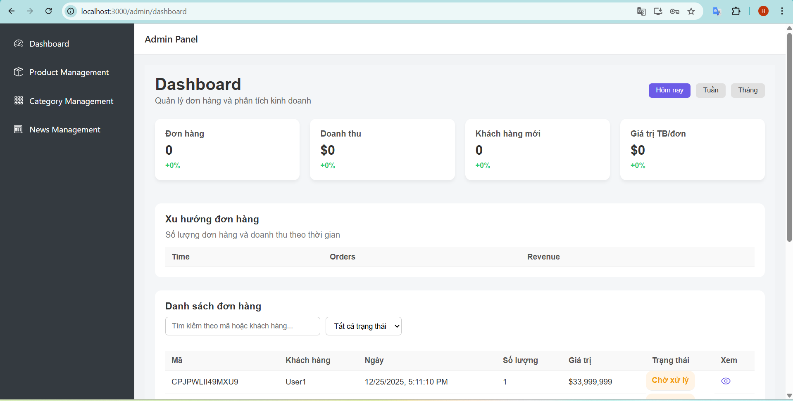

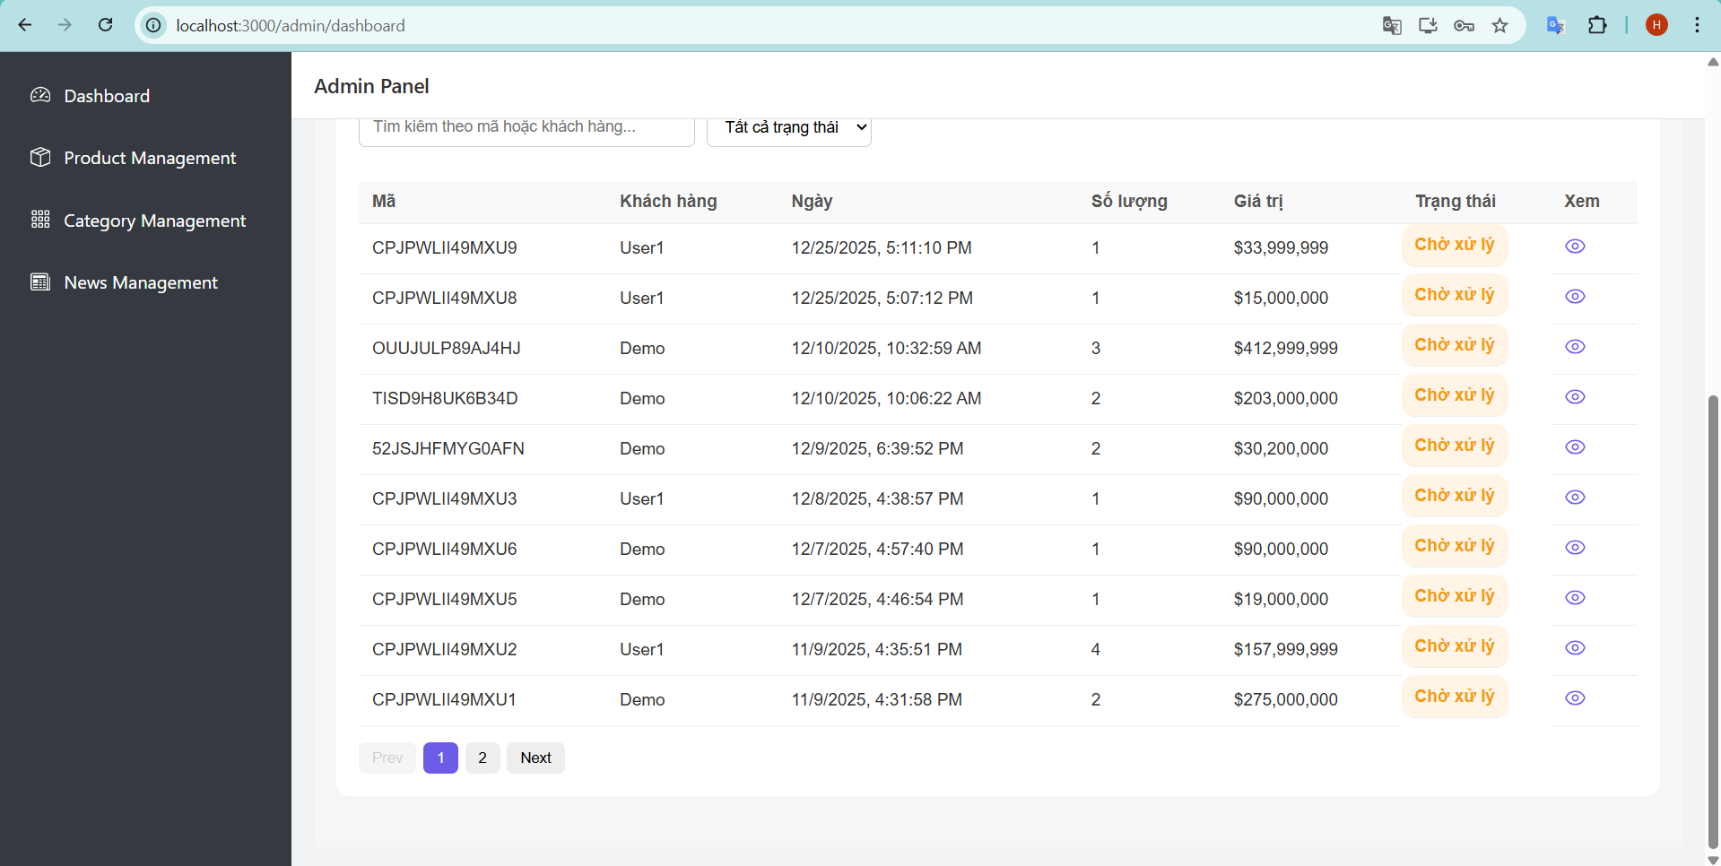

Product Management

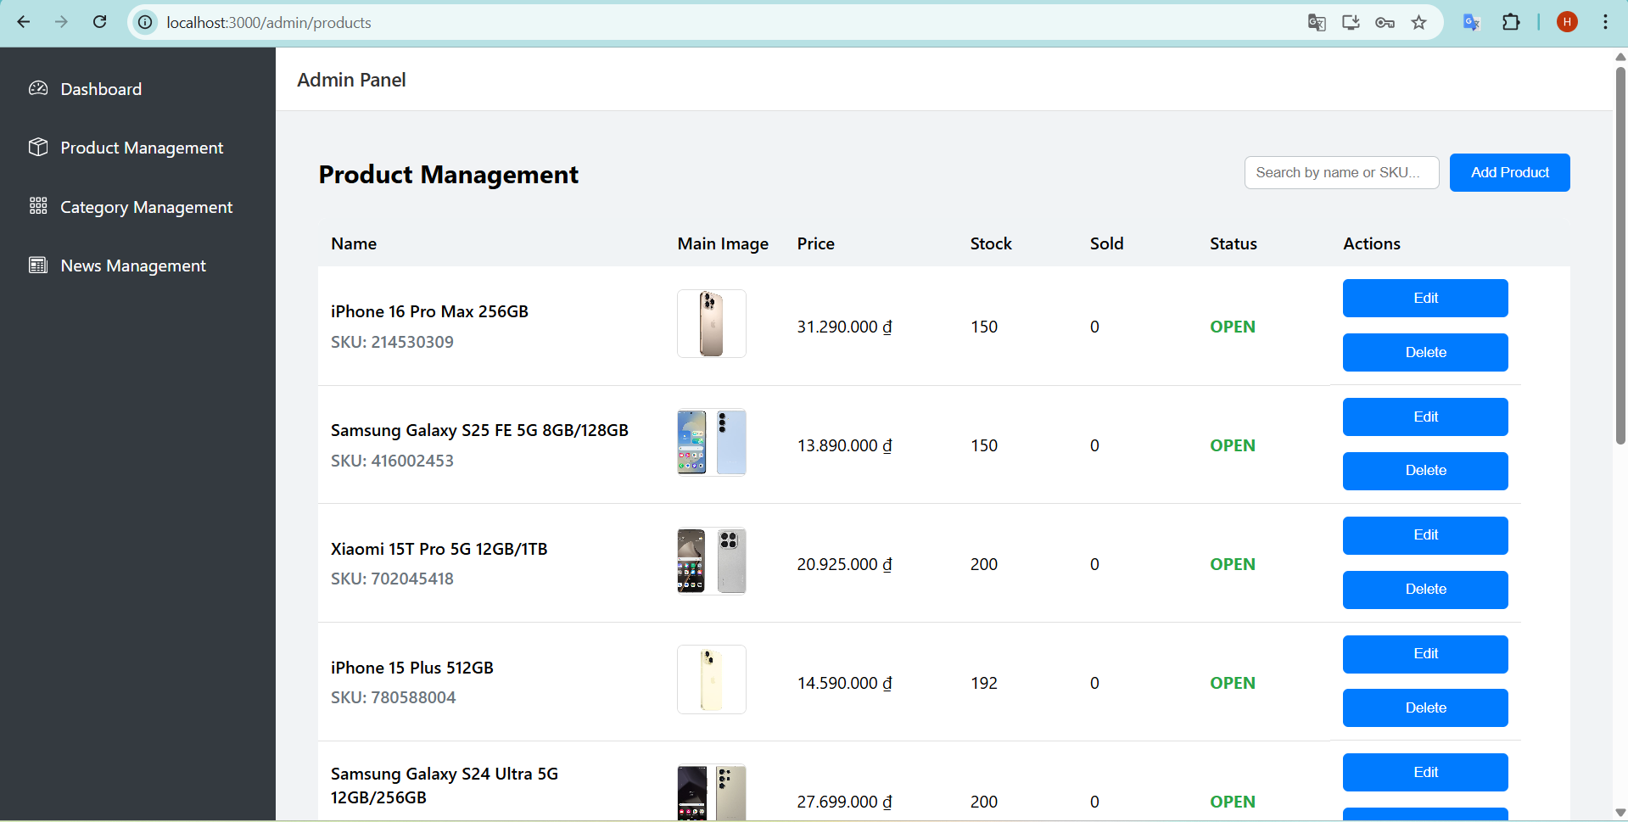

Add Product

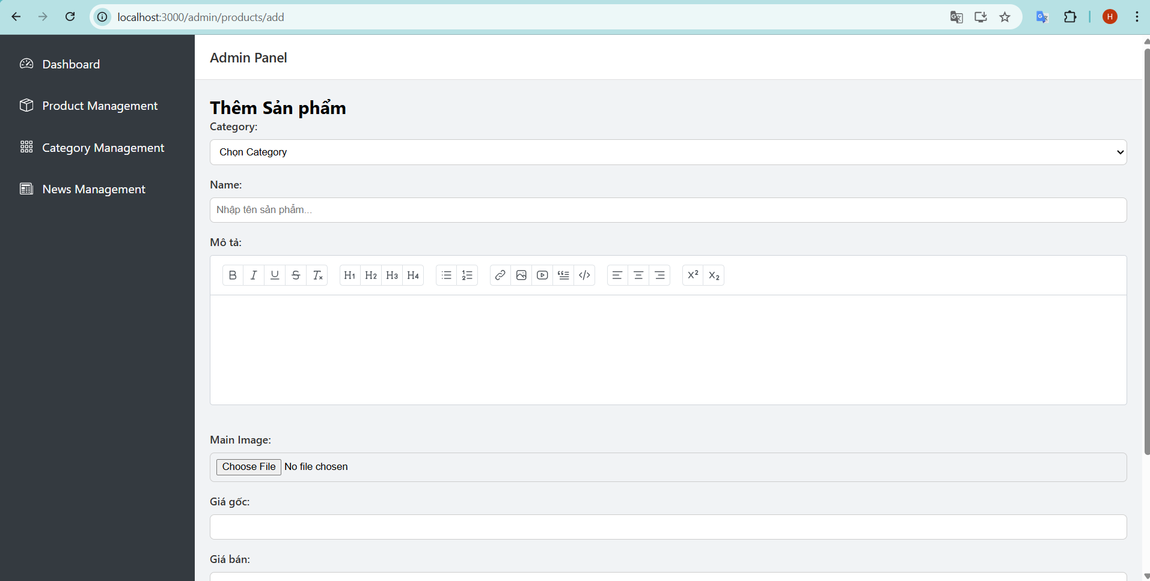

Edit Product

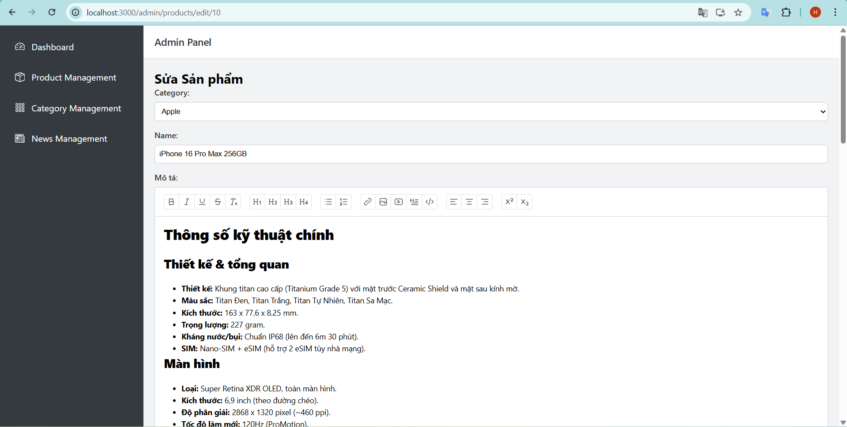

Category Management

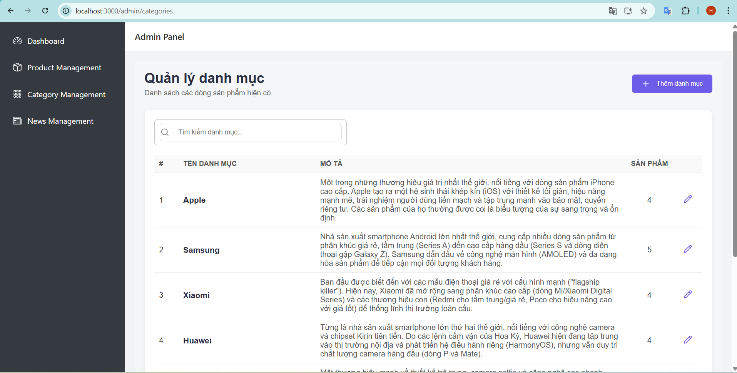

Add Category

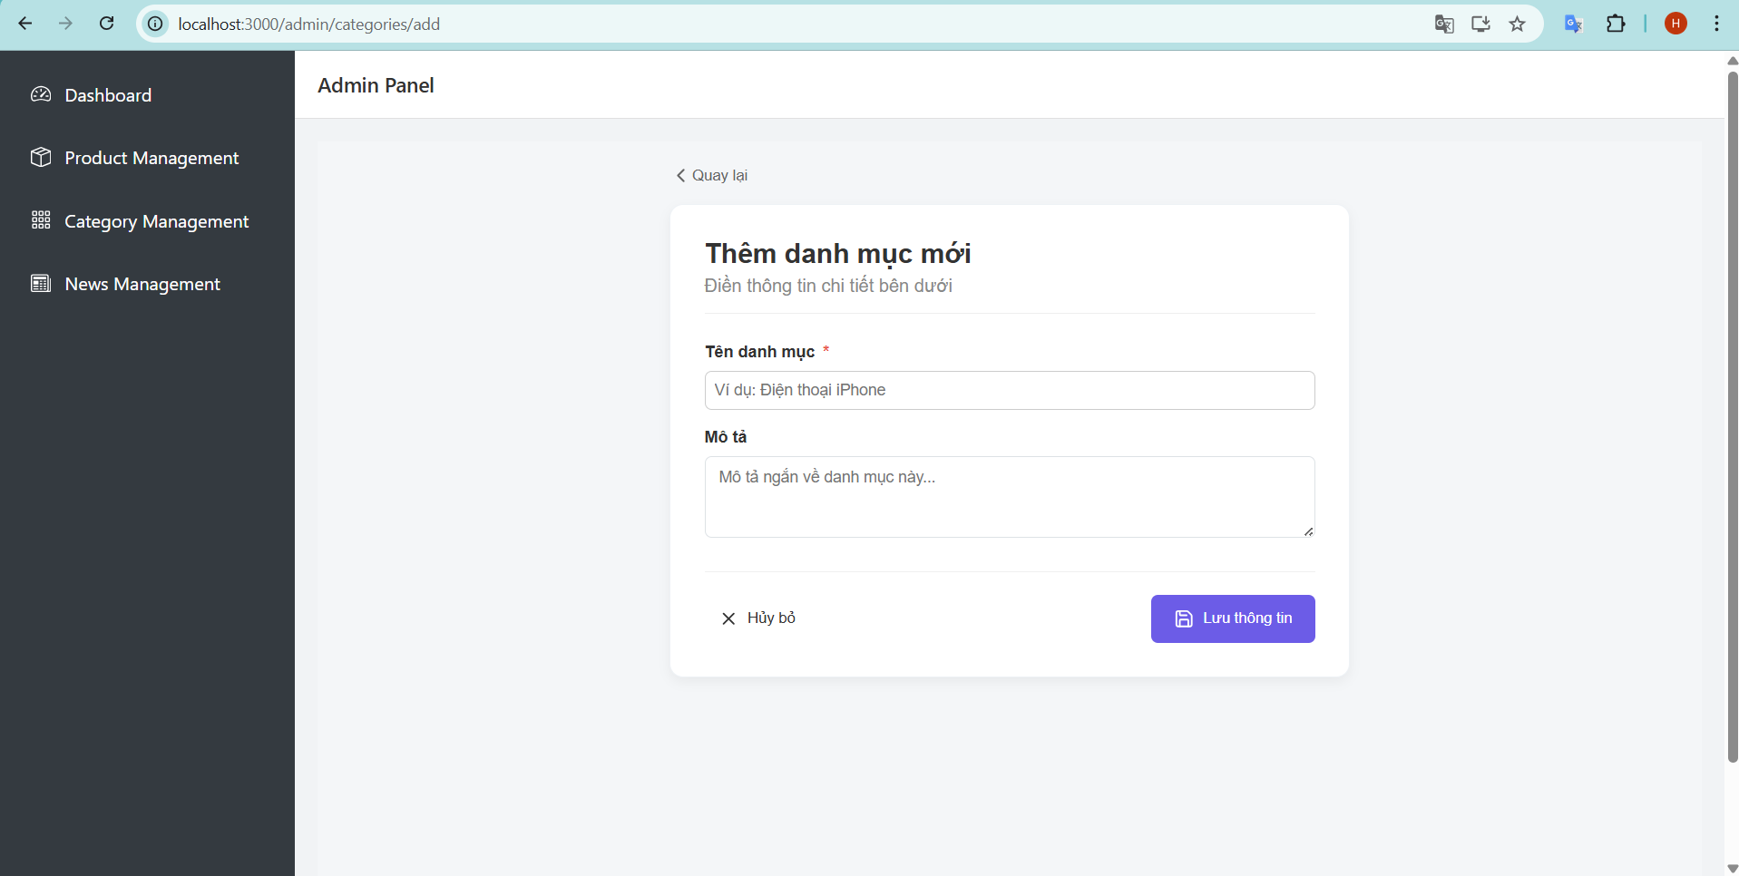

Edit Category

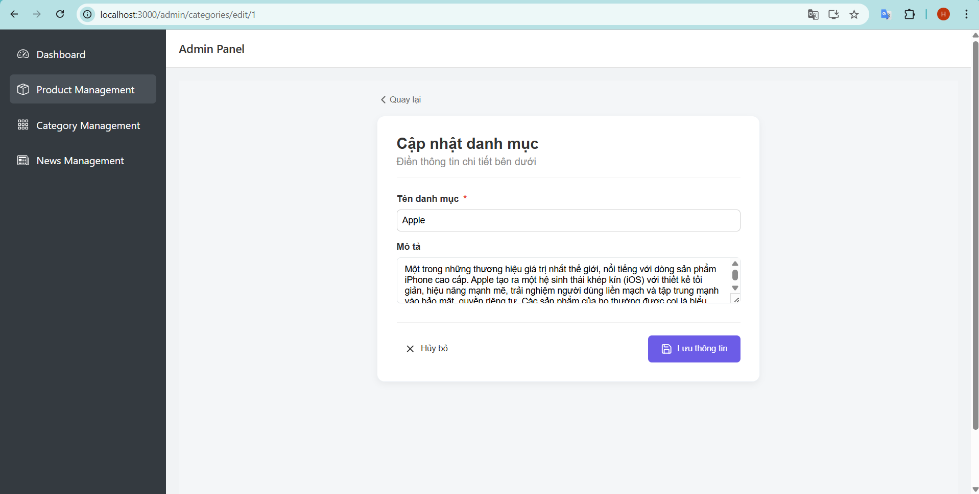

News Management

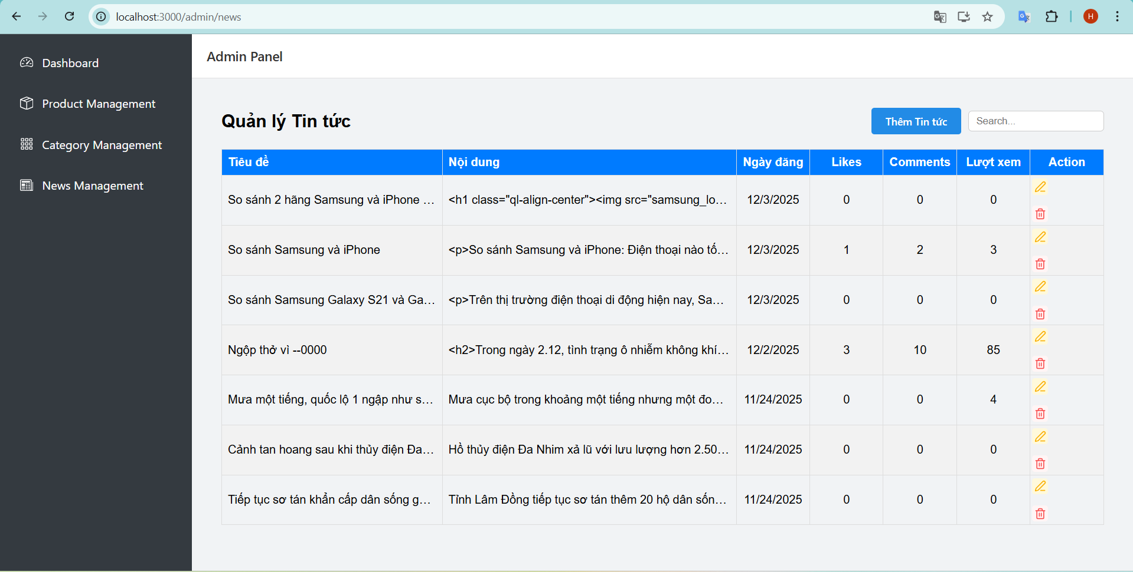

Add News

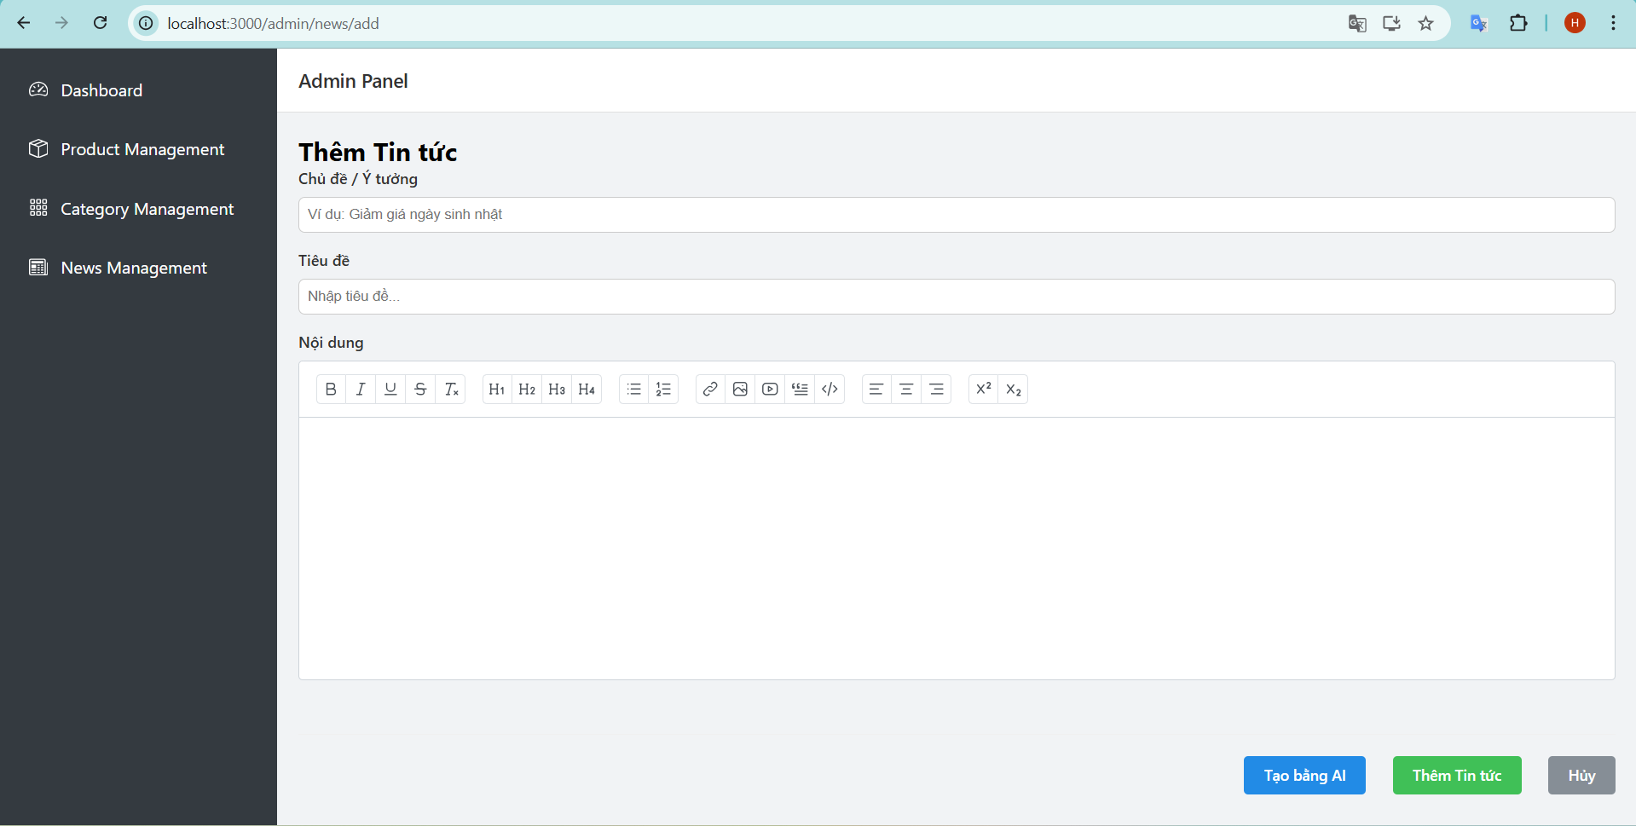

Edit News

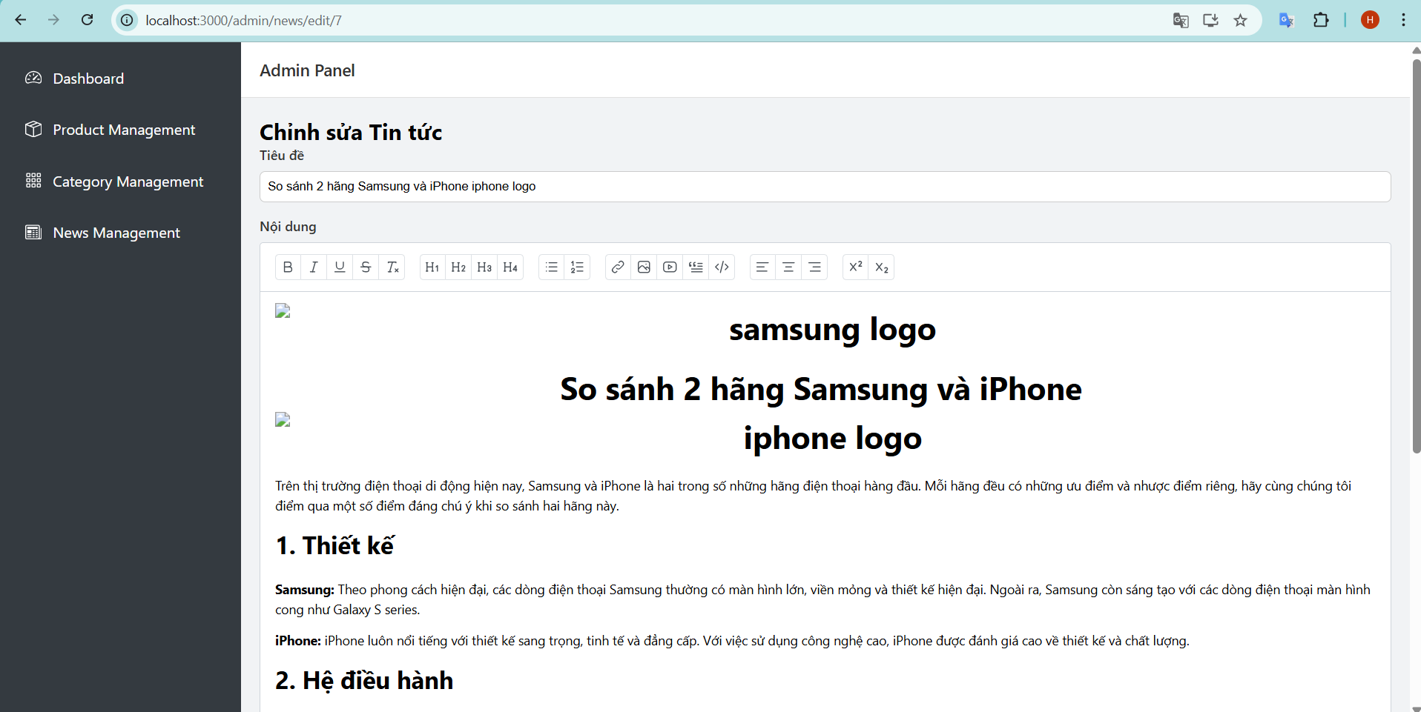

**USER**

Login

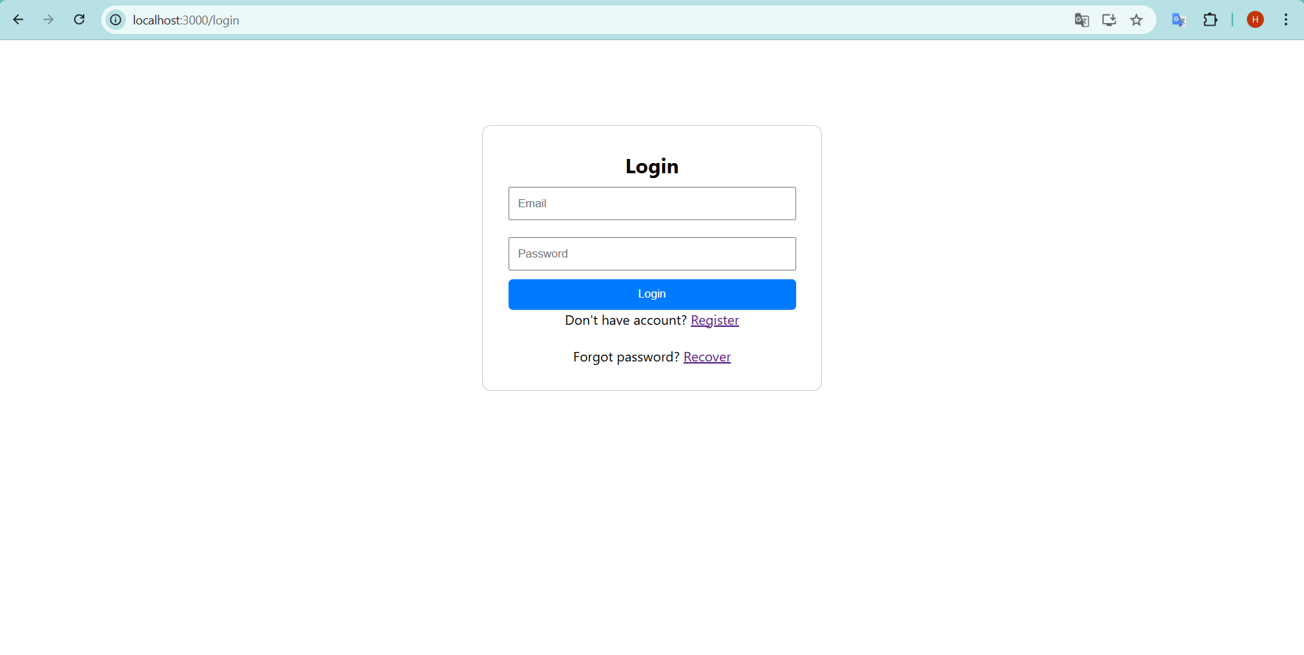

Register

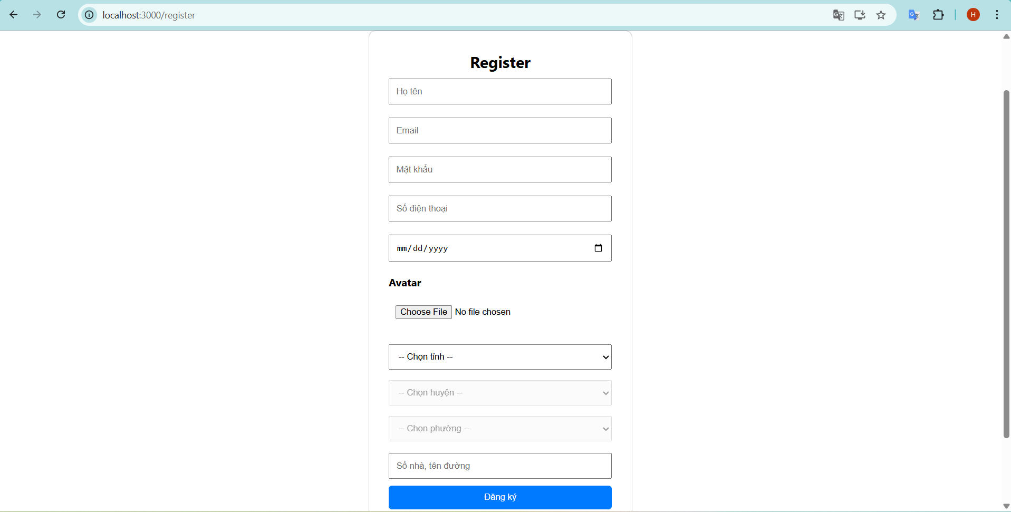

OTP

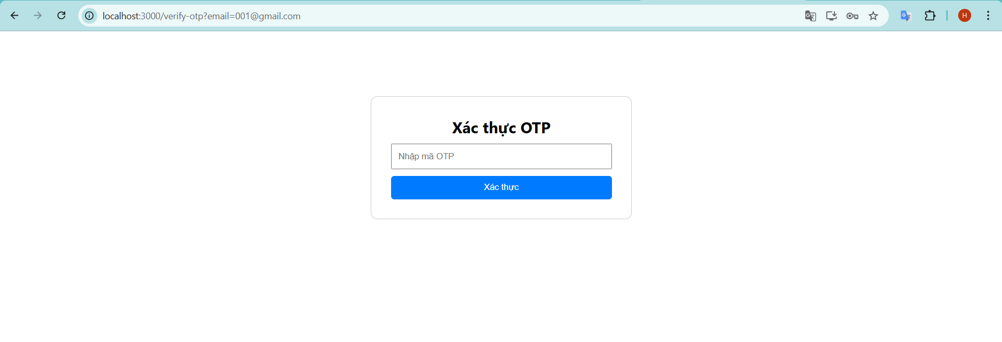

Forgot password

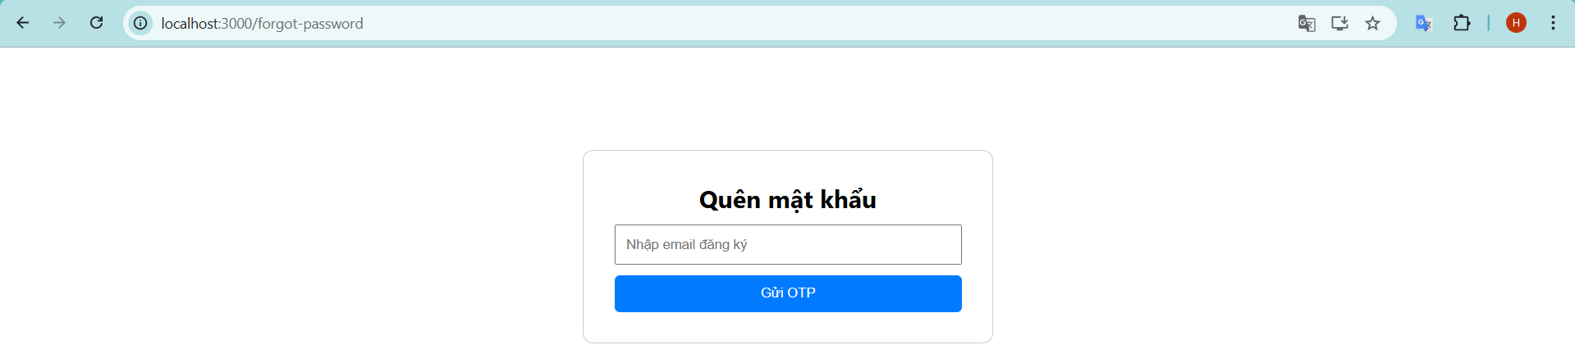

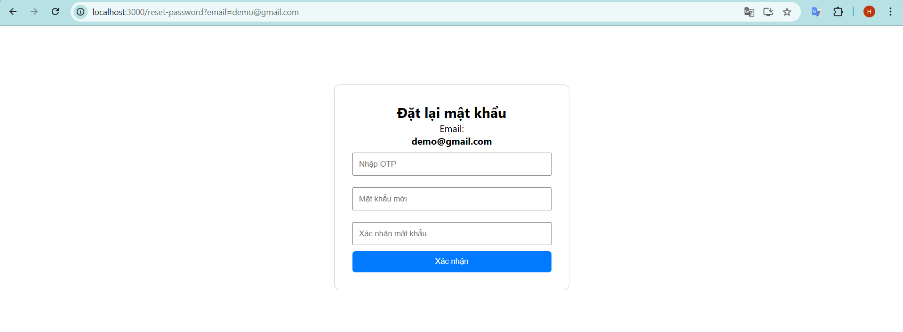

Home

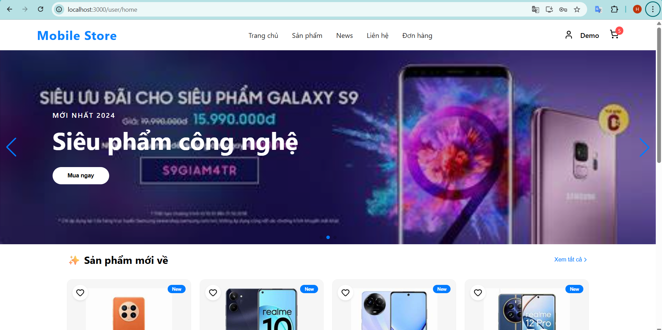

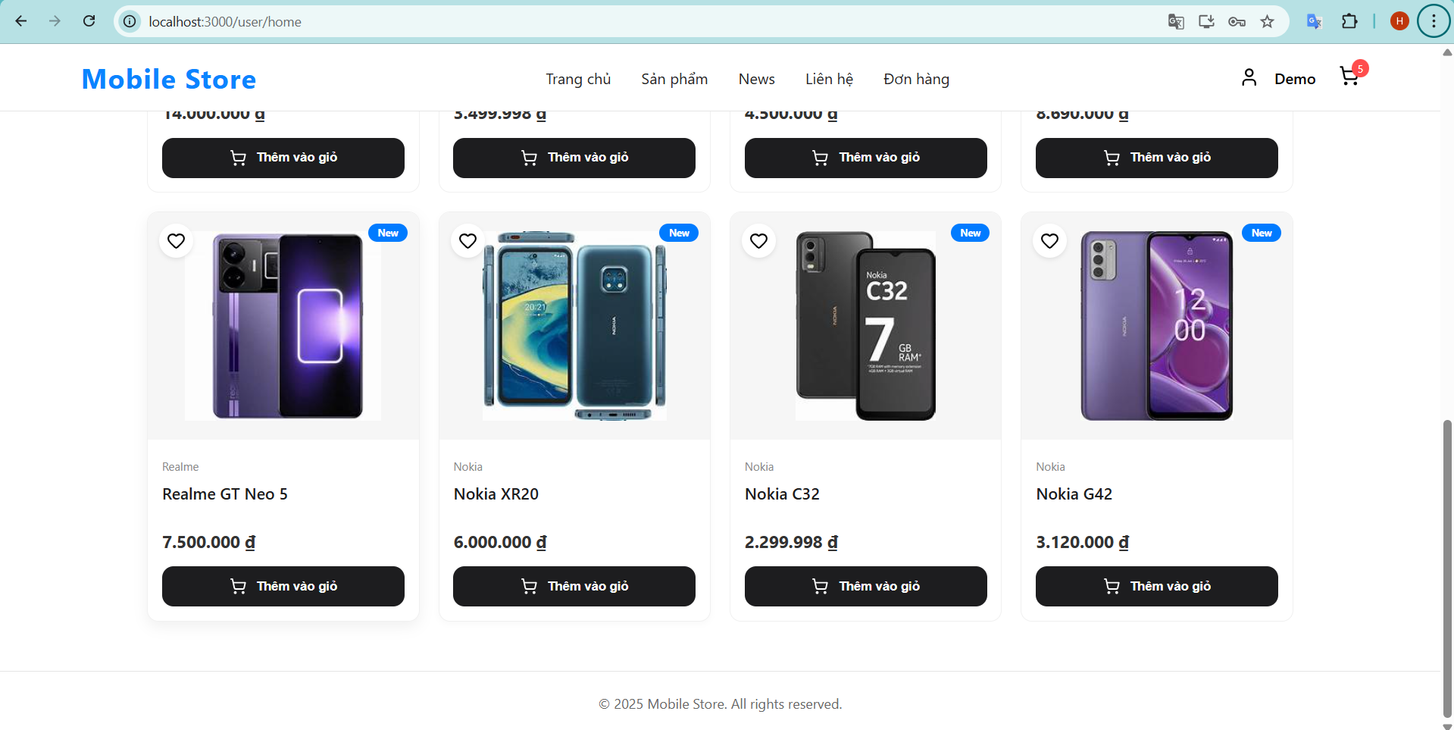

Product

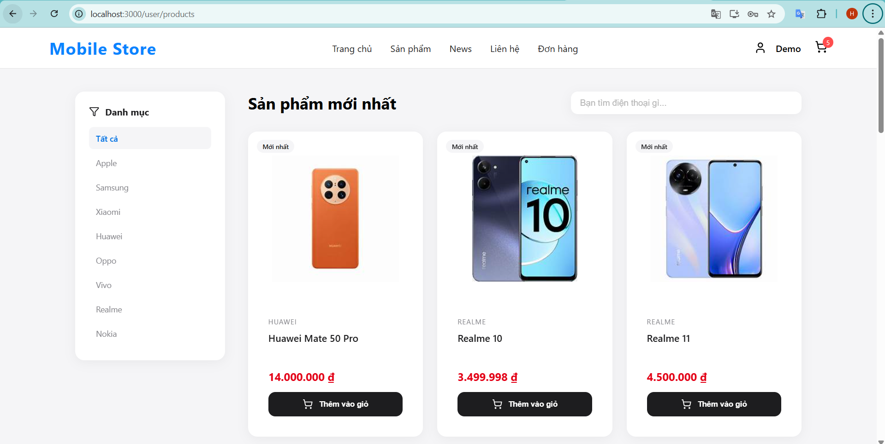

Product Detail

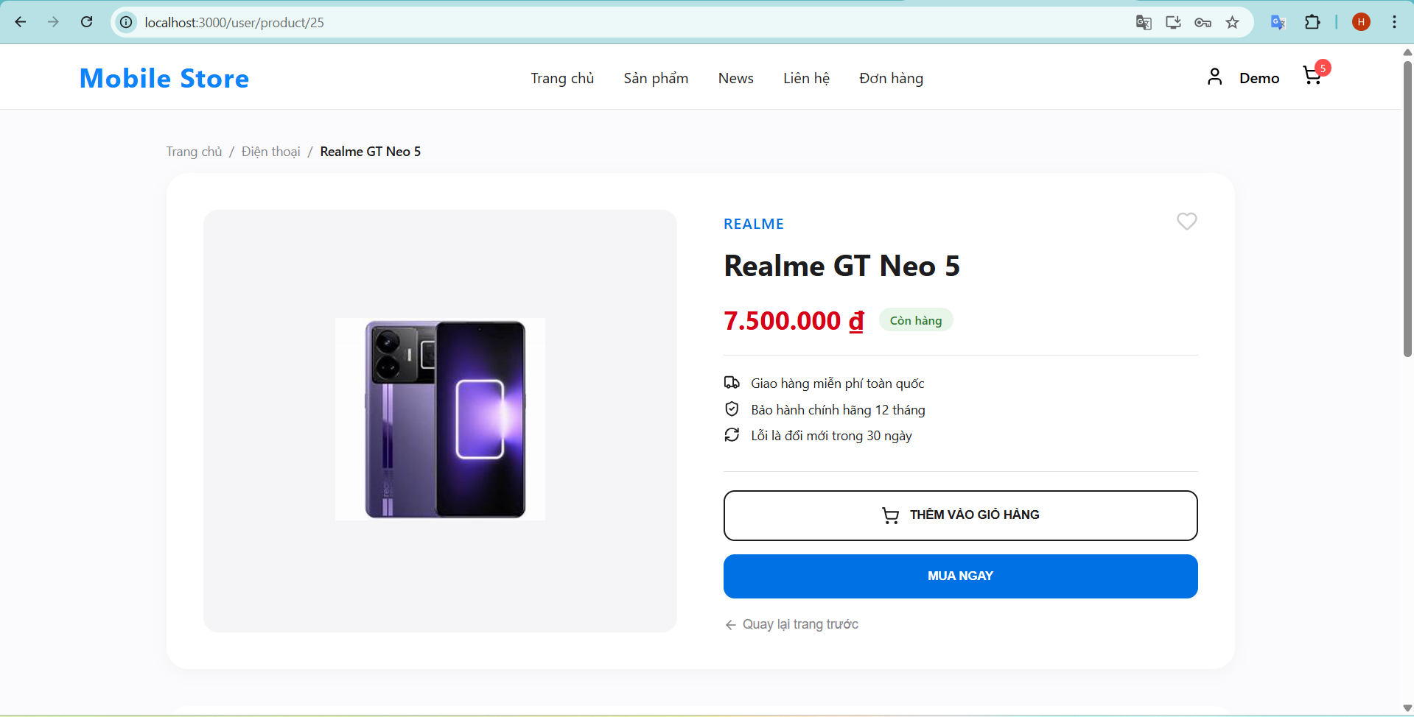

Cart

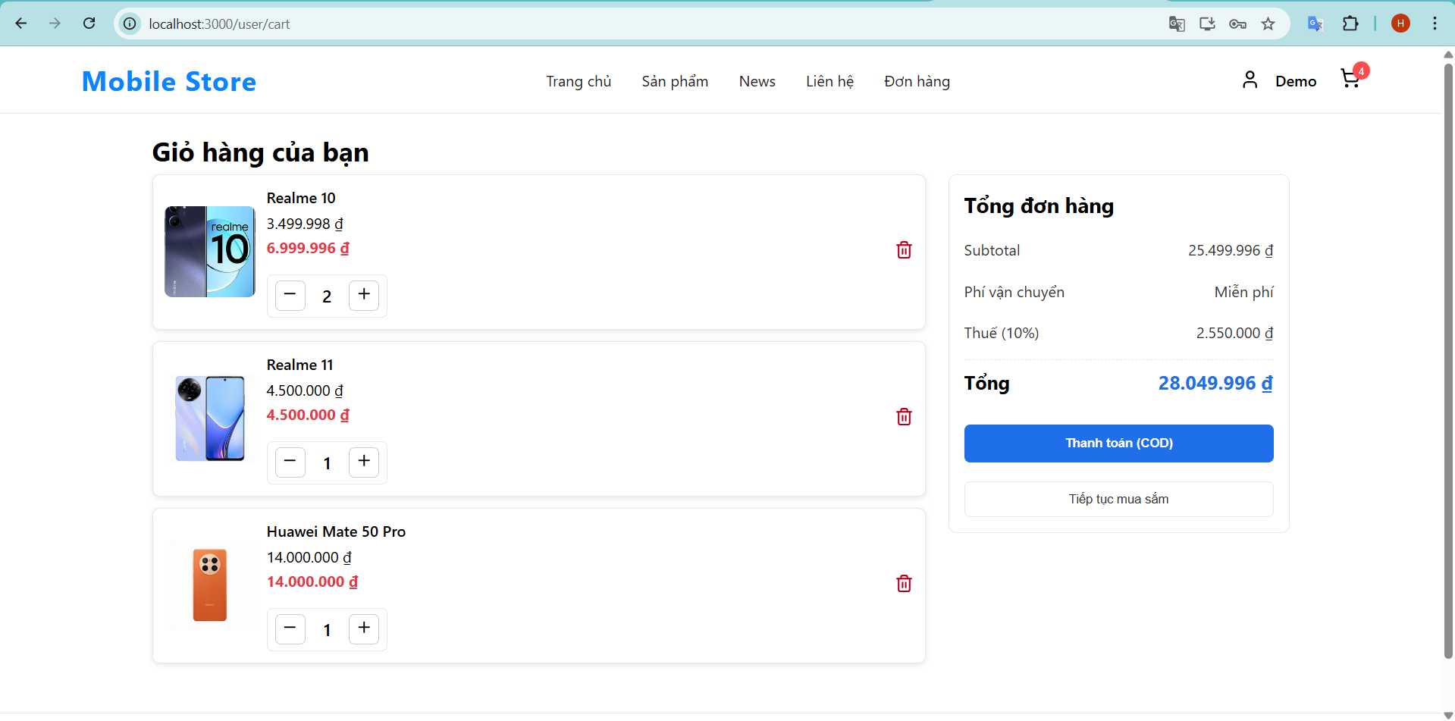

Checkout

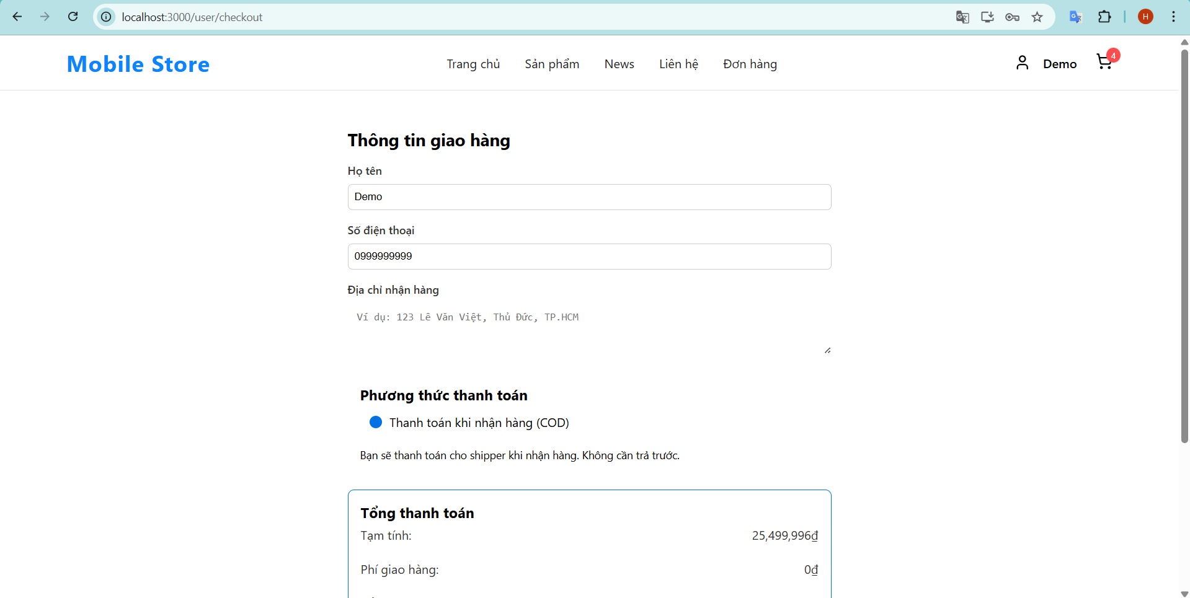

Order

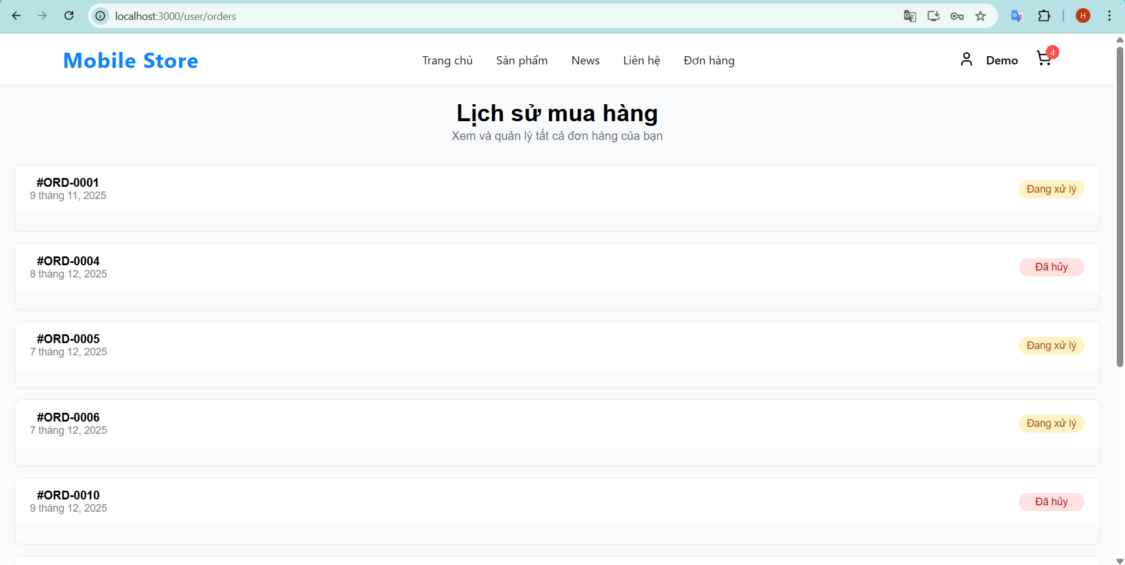

New  
  
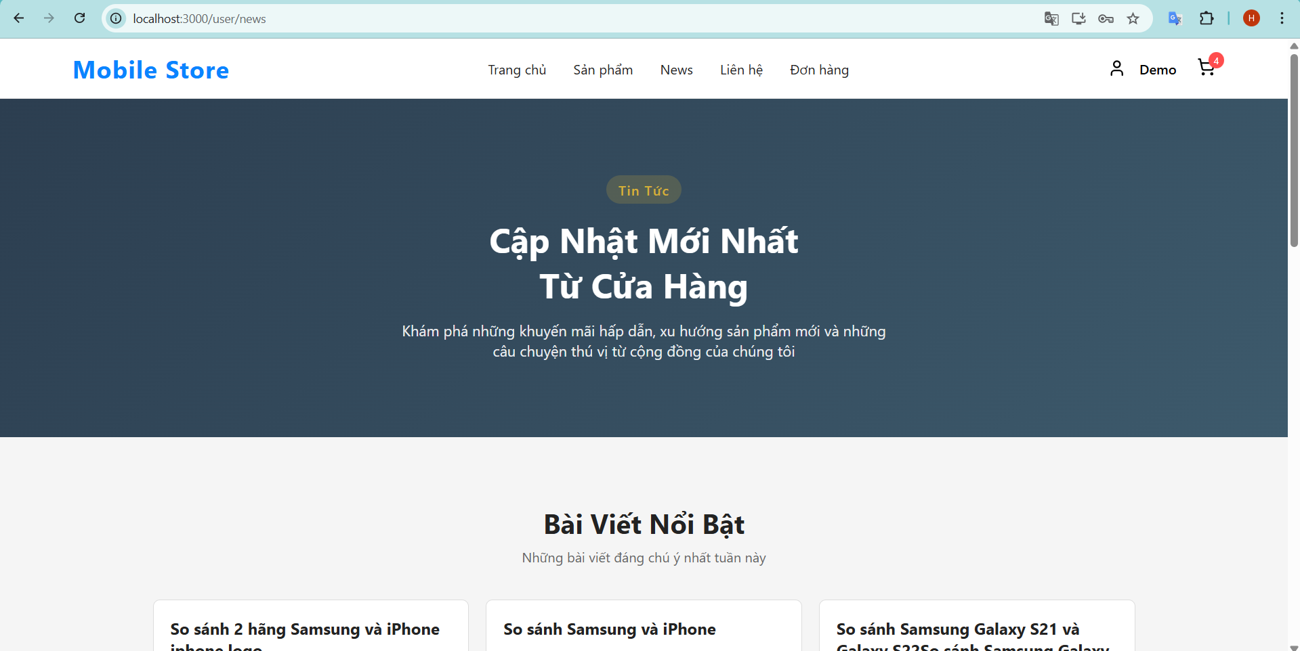

New Detail

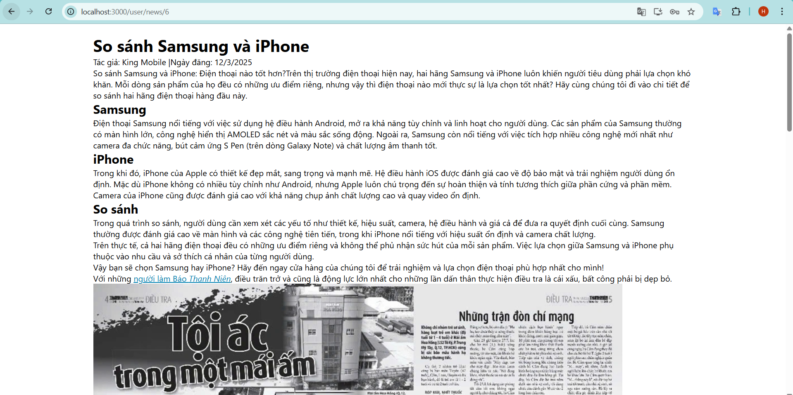

Contact

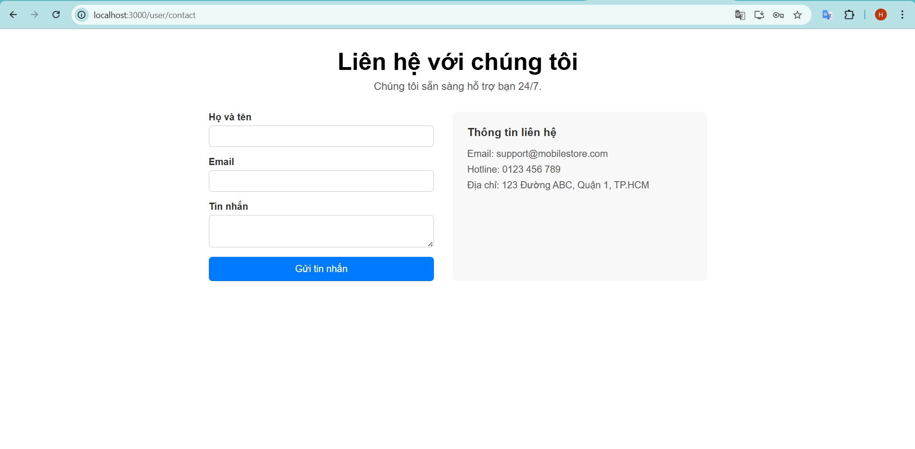

**TASK SHEET REVIEW 3**

|  |  |  |  |  |  |  |  |  |
| --- | --- | --- | --- | --- | --- | --- | --- | --- |
| **Project Ref. No.:** | | **Project Title:** | **Activity Plan Prepared By:** | **Date of Preparation of Activity Plan:** | | | | |
| **Sr.**  **No.** | **Task** | **Actual Start Date** | | **Actual Days** | **Team Mate Names** | **Status** |
| 1 | Dashboard  Order Admin | King Shop | All member | 1/12/2025 | |  | Hung | Completed |
| 2 | Product Management | 1/12/2025 | |  | Hoang | Completed |
| 3 | Category Management | 1/12/2025 | |  | Hoang | Completed |
| 4 | New Management | 1/12/2025 | |  | Hung | Completed |
| 5 | Login | 1/12/2025 | |  | Hoang | Completed |
| 6 | Regester | 1/12/2025 | |  | Hoang | Completed |
| 7 | Home | 1/12/2025 | |  | Hoang | Completed |
| 8 | Product | 1/12/2025 | |  | Hoang | Completed |
| 9 | Cart | 1/12/2025 | |  | Hung | Completed |
| 10 | Checkout | 1/12/2025 | |  | Hung | Completed |
| 11 | Order | 1/12/2025 | |  | Hung | Completed |
| 12 | New | 1/12/2025 | |  | Hung | Completed |
| **Date: 17/12/2025** | | | | | | | | |
| Signature of Instructor:  **Mr. Tran Phuoc Sinh** | | | | | Signature of Team Leader:  **Nguyen Duy Anh** | | | |